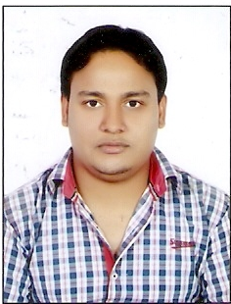
CURRICULUM VITAE

MD Ejaz Alam

E-mail:alamejaz01@gmail.com, ejaz_alam92@yahoo.com

Mob: (9074537283)

CAREER OBJECTIVE:
- To be the part of an enthusiastic work environment, where I can use my technical skills to accomplish organizational goals.

ACADEMIC BACKGROUND:
Passed B.E in ELECTRICAL & ELECTRONICS ENGINEERING from J N C T Bhopal Approved by AICTE.

Institute/University | Degree/Examination | Percentage | Year
Jnct/RGPV | B.E | 7.10 (CGPA) | 2011-2015
Sns college hajipur | 12th | 61.6% | 2010
High School Sontha,  Kishanganj / BSEB | 10th | 59.60% | 2008

- WORK EXPERIENCE:
- Currently I am working in Inox wind ltd. on off Role Basic from June 2016 to till date.
- Pervious I was working tesla transformer ltd Bhopal on off Role Basic from september 2015 to May 2016
- 45 days industrial training in PLC & SCADA from Ai Automation Bhopal. Work at Allen Bradley

TRAININGS:
- MPPTCL ( MADHYA PRADESH POWER TRANSMISSION CORPORATION LIMITED) at BHOPAL for 21days

WORKSHOP ATTENDED:

- Attended workshop on “PLC ,SCADA,VFD with AI AUTOMATION Pvt. Ltd Bhopal”
- Attended workshop on EMBEDDED SYSTEM with ISTE CHAPTER, JNCT Bhopal

AREA OF INTEREST:
- Power System
- Electrical Machine
- Mathematics

CO-CURRICULAR ACTIVITIES:
- Participated in JAIVISION 2013 for Tech Industrial Problem at JNCT&S

FINAL YEAR PROJECT:
- Performance enhancement of power system by using static VAR compensator

STRENGTHS:
- The ability to Work in a team.
- Leadership Qualities.
- Hard-working with lots of patience.
- Positive Attitude.
- Quick Learner.
- Self confidence.
- Self motivator.

HOBBIES:
- Bike ridding
- Listening music
- Web searching

PERSONAL DETAILS:
NAME : MD EJAZ ALAM DATE OF BIRTH : 24th Day of Oct, 1992
FATHER’S NAME : Kabirul Islam MOTHER’S NAME : Razia Begum
GENDER : Male
MARITAL STATUS : Single
NATIONALITY : Indian
PASSPORT No : N9293767 PERMANENT ADDRESS : Village. Katha Matha,
Po:-Dhanpat ganj, Dist:-Kishanganj
Pin:-855115 Mob no:- 9074537283

DECLARATION:
I hereby declare that the above mentioned particulars are true to the best of my knowledge and belief.
Place : JAORA,
Date :

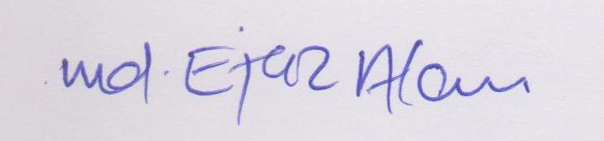
(SIGNATURE)

